TUNKU ABDUL RAHMAN UNIVERSITY OF MANAGEMENT AND TECHNOLOGY FACULTY OF COMPUTING AND INFORMATION TECHNOLOGY
ACADEMIC YEAR 2024/2025 JANUARY EXAMINATION
BACS2103 SOFTWARE QUALITY ASSURANCE AND TESTING

MONDAY, 13 JANUARY 2025 TIME: 9.00 AM - 11.00 AM (2 HOURS)

BACHELOR OF INFORMATION TECHNOLOGY (HONOURS) IN SOFTWARE SYSTEMS DEVELOPMENT

BACHELOR OF SOFTWARE ENGINEERING (HONOURS)

Instructions to Candidates:

Answer ALL questions. All questions carry equal marks.

ABC Glofoxx is deciding to develop an online wellness studio management software to spread wellness in Malaysia community. This software shall be running in the main mobile operating systems which are Apple iOS and Google Android that support smartphones, smartwatches, smart glasses, and tablets . The aim of this software is to ease the process of building wellness business by creating a seamless experience for wellness center and their members. The wellness studio management software helps to reduce admin time, boost revenue, and grow the business. Essential functionalities that will he offered by this software are manage membership, bookings, and payment directly from the software. In addition, the software can be used to send messages, emails, and push notifications to the target members efficiently. The software also able to generate performance reports to show the growth of the membership and engagement to higher revenue.

- Identify ONE (1) most appropriate software testing principle which needs to be emphasised for the development of the online wellness studio management software. Justify why this principle is important. (2 + 4 marks)

Testing activities should start as early as possible.
Testing activities should start as early as possible in the software life cycle and focus on defined goals. This contributes to finding defects early to reduce cost and rate of defective products.

- ABC Glofoxx is planning to conduct varieties of testing types to test both versions of online wellness studio management software. Analyse THREE (3) black box testing types which are crucial to be conducted. Justify your choices. (9 marks)

Smoke Testing
- To ensure that the most important functions work such as manage membership, bookings, and payment directly from the software.
- Goal: Confirm that the build is stable enough to proceed with further testing.
Load Testing
- To identify the maximum operating capacity of an application.
- Goal : Make sure the system works well under the expected user load.
Stress Testing
- Tests the system beyond its normal limit
- Goal: To find the system’s breaking point.

- The proposed online wellness studio management software contains a few integrated modules to work together. The modules are member management, member payment, member studio, marketing and sales solutions, business operations, and reporting. As the software testing team leader, you have selected an incremental integration testing approach. With the aid of a diagram, explain this approach and outline TWO (2) advantages of the approach (6 + 4 marks)

[Total: 25 marks]

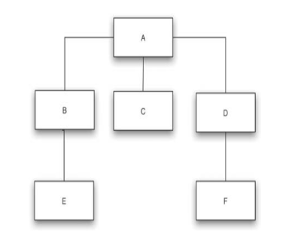
- Each module needs to have ONE driver module. E, C, F are tested first. Then B-E, D-F. Lastly, A-B-C-D-E-F.
- Incremental approach required less works. This is because 5 drivers and 5 stubs required for non-incremental but only 5 drivers / stubs required for incremental approach.
- Programming errors can be detected earlier in incremental approach.
- Debugging is easier in incremental approach.

  - Figure 1 shows a code segment of the online wellness studio management software mentioned in Question 1, determining the membership registration status of an age input.

importJava. util.Scanner;

class Main {
public static void main (String [] args) { Scanner in = new Scanner (System.in);

System.out.print ("How old are you?''); int age = in.nextlntO;
if (age < 17)
System.out.println ("Sorry, you are not quite old to register for the wellness studio membership'');
else
System.out.println ("Yeah! Happy registering!'');
}
}
Figure 1

    - Construct a Control Flow Graph (CFG) for the code segment shown in Figure 1. (5 marks)
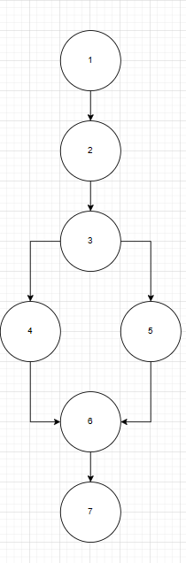

    - Calculate the Cyclomatic Complexity from the CFG created in Question 2 a) (i). (2 marks)

Cyclomatic Complexity = 7-7+2 = 2

    - Provide basis path(s) based on the result in Question 2 a) (ii). (2 marks)

Path 1: 1-2-3-4-6-7
Path 2: 1-2-3-5-6-7

  - A membership verification form has been designed for the online wellness studio management software and you have been required to test the form. A registered member enters either their email and password or membership id and password to gain access to the software. If the verification fails, an error message must appear accordingly. As the assigned software tester, you have decided to use Cause Effect Graph (CEG) as a systematic technique to derive an efficient set of test cases by analysing the relationships between the different inputs and outputs to test the mentioned software behaviour.

- Construct a CEG for the above scenario. (6 marks)

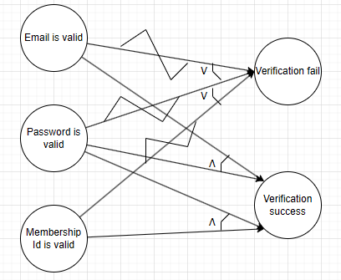

- Produce a decision table from the CEG based on Question 2 b) (i). (5 marks)

Decicion table |  | TC1 | TC2 | TC3 | TC4 | TC5 | TC6
Conditions | Email valid? | N | Y | - | - | Y | -
 | Password valid? | Y | N | Y | N | Y | Y
 | Membership valid? | - | - | N | Y | - | Y
Actions | Verification success | N | N | N | N | Y | Y

  - As part of software testing process for the online wellness studio management software, identifying and reporting defect effectively is important. Analyse what is defect priority and how it can help in defect reporting during a defect management process. (5 marks)

[Total: 25 marks]

Defect priority is the urgency of fixing a reported defect based on its business impact. It helps to support release planning by organizing which bugs must be resolved first. It also helps testers, developers, and managers clearly understand which defects are urgent and why.

Question 3

Techno Solutions is an independent software testing company which works on Software Quality Assurance (SQA), test operations, test automation technologies. They are passionate to deliver excellent quality application, develop SQA tools which can reduce the software release cycle. They are providing services such as test automation services, outsource testing services, SQA services, remote SQA team, and SQA outsourcing.

- Analyse THREE (3) main differences between Software Quality Assurance (SQA) and Software Quality Control (SQC) which Techno Solutions needs to recognise before they can appropriately apply SQA to develop excellent quality applications. (6 marks)

Software Quality Control | Software Quality Assurance
Product focus | Process- oriented
Occurs after development, focus on identifying defects | Focus on detecting errors or defects early
Aim to evaluate and verify the quality of the final product | Aim to reduce the cost and rate of defective products

- Describe TWO (2) SQA activities that Techno Solutions can implement to ensure high qualily testing services for their clients. (4 marks)

- Ensure suitable work environment for SQA team
  - Importance of communication between testers and developers to avoid misunderstandings.
- Optimize the use of automated tests
  - To improve the quality of a software, automated testing is definitely worth taking into consideration.

- As part of SQA services, Techno Solutions implements software quality metrics in measuring the quality aspects of software products, software processes, and software projects for accurately describe the status across the project life cycle.

  - Table 1 shows the number of code errors and the relative weight for each error severity class in a recently developed software. Calculate the Total NCE, the Weighted NCE (WCE) for each severity class, the Total WCE, the Code Error Density (CED), and the Weighted CED (WCED) if the thousands of lines of code (KLOC) is 75. (5 marks)

Table 1
Severity Class |  | Relative Weight |  | Number of Code Error (NCE)
High |  | 20 |  | 65
Medium |  | 15 |  | 110
Low |  |  | 10 | 155

Severity Class | Relative Weight | Number of Code Error (NCE) | Number of Weighed Code Error (WCE)
High | 20 | 65 | 20 * 65 = 1300
Medium | 15 | 110 | 15 * 110 = 1650
Low | 10 | 155 | 10 * 155 = 1550
Total NCE = 65 + 110 + 155 = 330
Total WCE = 1300 + 1650 + 1550 = 4500

CED
= NCE / KLOC
= 330 / 75
= 4.4

WCED
= WCE / KLOC
= 4500 / 75
= 60

  - Table 2 shows the list of development milestones of a software project being handled by Techno Solutions. The project has produced 350 pages of document and 155 pages are reused from previous projects. Out of 75 KLOC, 65% of the codes are reused from few previous projects too. Calculate Development Productivity (DevP), Code Reuse (CRe), and Documentation Reuse (DocRe). (5 marks)

Table 2
Milestone | Hours of working
Ml | 145
M2 | 55
M3 | 88
M4 | 115
MS | 45
M6 | 144

DevP
= DevH / KLOC
= (145 + 55 + 88 + 115 + 45 + 144) / 75
= 592 / 75
= 7.8933

CRe
= ReKLOC / KLOC
= (75 * 0.6) / 75
= 45 / 75
= 0.6

DocRe
= ReDoc / NDoc
= (350 - 155) / 350
= 195 / 350
= 0.5572

Question 3 c) (Contin ued)

  - Techno Solutions currently working on an e-commerce application which is expected to operate for 24 hours daily in one year of services. However, the total time of the application that not able to provide some functionalities is 124 hours. From the total hours, 34 hours the application is not able to perform its vital functionalities. Furthermore, a total of 20 hours from the total hours the application is totally failed. Calculate Full Availability (FA), Vital Availability (VitA), and Total Unavailability (TUA) of the application. (5 marks)

[Total: 25 marks]
NYSerH = 24 * 365 = 8760

FA
= (8760 - 124) / 8760
= 8636 / 8760
= 0.9859

VitA
= (8760 - 34) / 8760
= 8726 / 8760
= 0.9961

TUA
= 20 / 8760
= 0.00228

Question 4

- Techno Solutions as mentioned in Question 3 would like to implement Total Quality Management (TQM) as a management framework to achieve customers' satisfaction and to build a long-term success in their organisation.

- Outline how TQM can be implemented in Techno Solution. (3 marks)
Customer-Focused Approach: Emphasize customer satisfaction by consistently gathering feedback from clients using Techno Solutions’ testing and QA services, and using it to improve service quality.

- Identify TWO (2) guiding principles that define TQM. (4 marks)

- Customer-focused
  - The customer ultimately determines the level of quality. The customer determines whether the efforts were worthwhile.
- Total employee involvement
  - All employees participate in working toward common goals.
- Techno Solutions is implementing few SQA standards in conducting their daily services.

  - Analyse TWO (2) benefits which can be gained by Techno Solutions by applying the SQA
standards in their services. (4 marks)

- Better mutual understanding and coordination among development teams but especially between development and maintenance teams.
- Greater cooperation between the software developer and external participants in the project.

  - Differentiate Project Process Standard with Quality Management Standard. (6 marks)

Project Process Standard | Quality Management Standard
Focus on the methodologies for carrying out software development and maintenance projects. (How the process to be performed). | Focus on the organization’s SQA system, infrastructure and requirements, while leaving the choice of methods and tools to the organization. (What process to perform)
Examples: Capability Maturity Model Integration (CMMI) | Examples: Capability Maturity Model (CMM)

  - Techno Solutions uses Capability Maturity Model (CMM) to measure the quality of their organisation's software process. Due to some drawbacks, Techno Solutions has decided to change from CMM into Capability Maturity Model Integration (CMMI). Analyse TWO
(2) disadvantages of CMM and TWO (2) improvements made in CMMI to overcome the identified disadvantages. (4 + 4 marks)

[Total: 25 marks]

Disadvantages of CMM
- Lose perspective and forget that the real goal is to actually improve the processes.
- CMM does not specify a particular way of achieving those goals.
- CMM only helps if it is put into place early in the software development process

Improvements made in CMMI
- The 18 key process areas of CMM were replaced by 25 process areas.
- For each process area; objectives, specific practices and procedures are defined.

